**Class and Design Diagrams**

The user interface flowchart shown in Figure 1 shows the workflow for an employee to manage tasks and inventory.

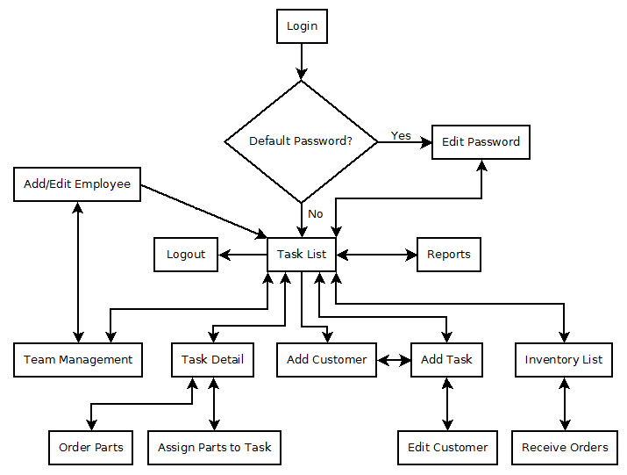

Figure

Figure 2 gives an overview of the system structure. The user interface classes retrieve data from the database via the web server. The data is then interpreted by the HttpJSONParser class into information the ArrayListBuilder class can use. The user interface then uses the ArrayListBuilder class to create an array list of objects based on the data retrieved from the database. Finally the user interface uses the data in the lists to create an interface.

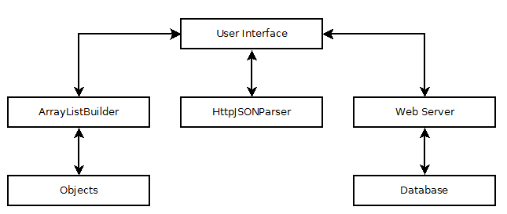

Figure

Figure 3 is a UML class diagram showing the inheritance relationship between the Inventory class and the InStock class. It also shows the aggregate relationships between the user interface classes and the ArrrayListBuilder class.

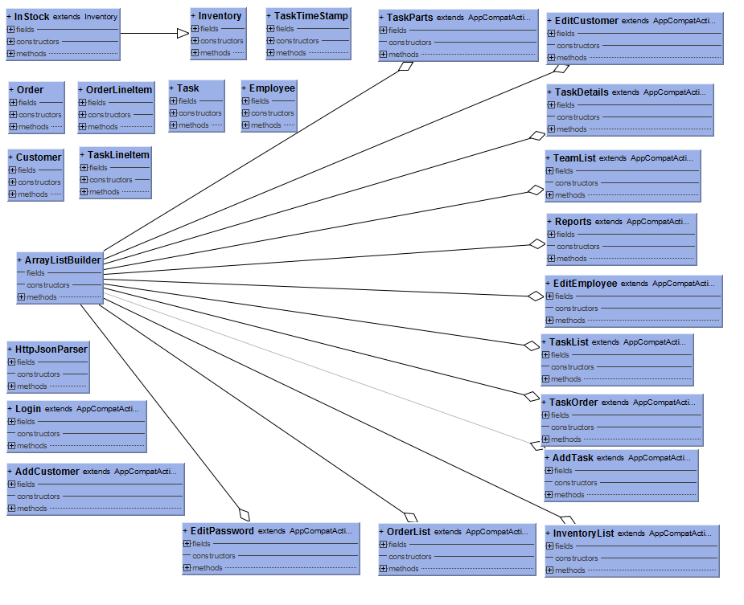

Figure

Figure 4 shows the database structure.

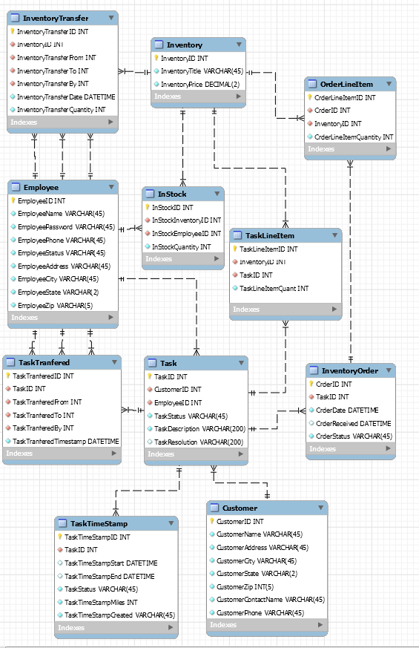

Figure